**Different Account EC2 Snapshot share**

: First go to ec2 console

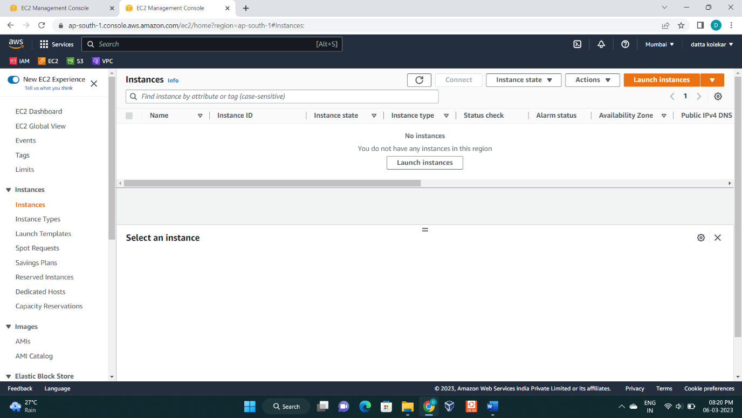

: Then click on **lunch instance** and select name, key pair and then lunch instance.

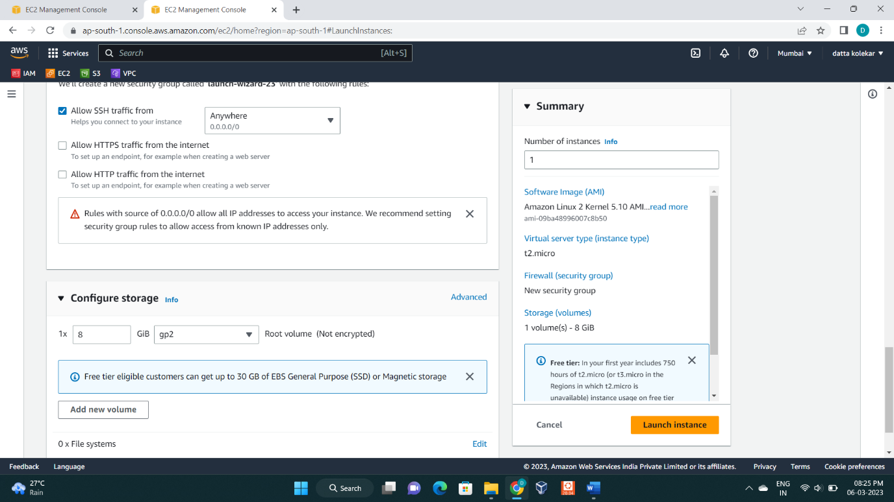

: Then show this interface

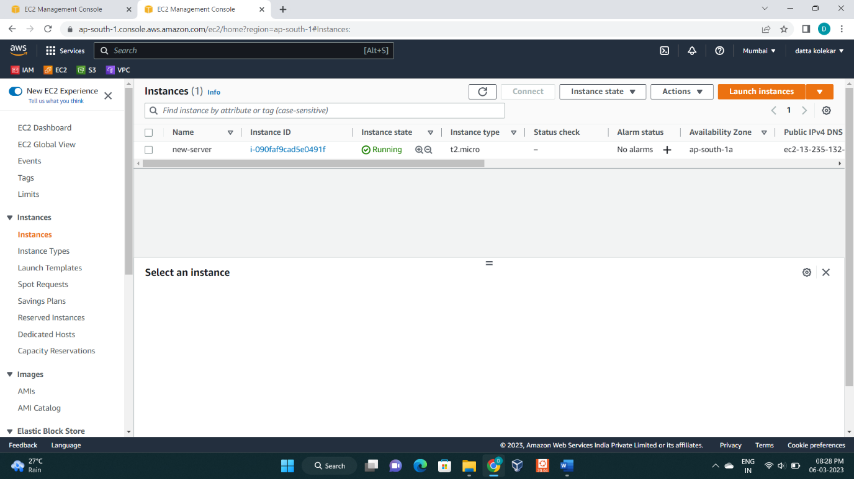

: Now go to **volumes** option

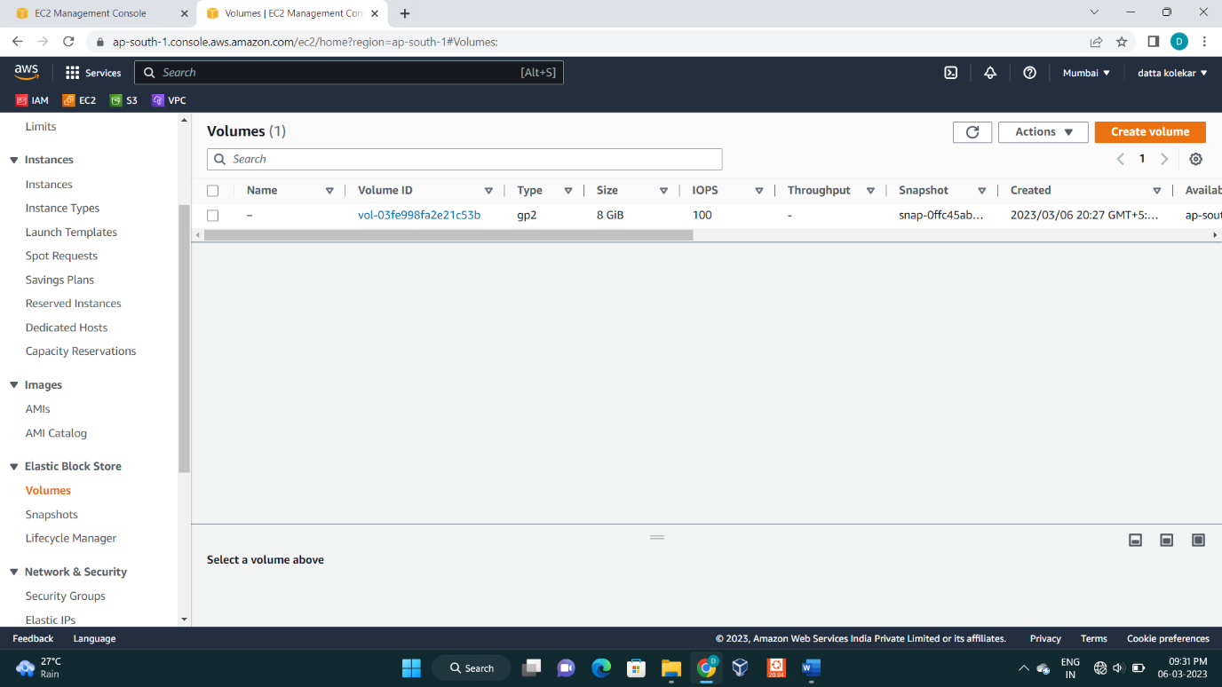

: Click on **create volume**

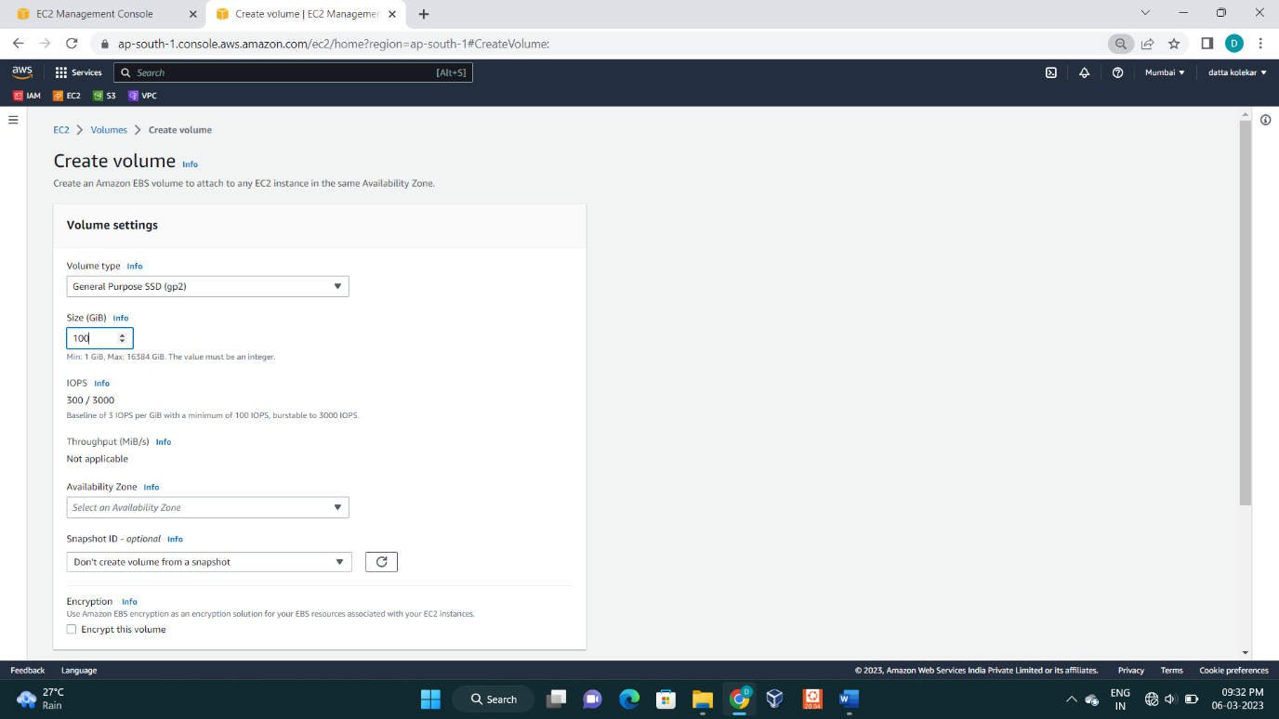

: Allocate size and click on **create volume**

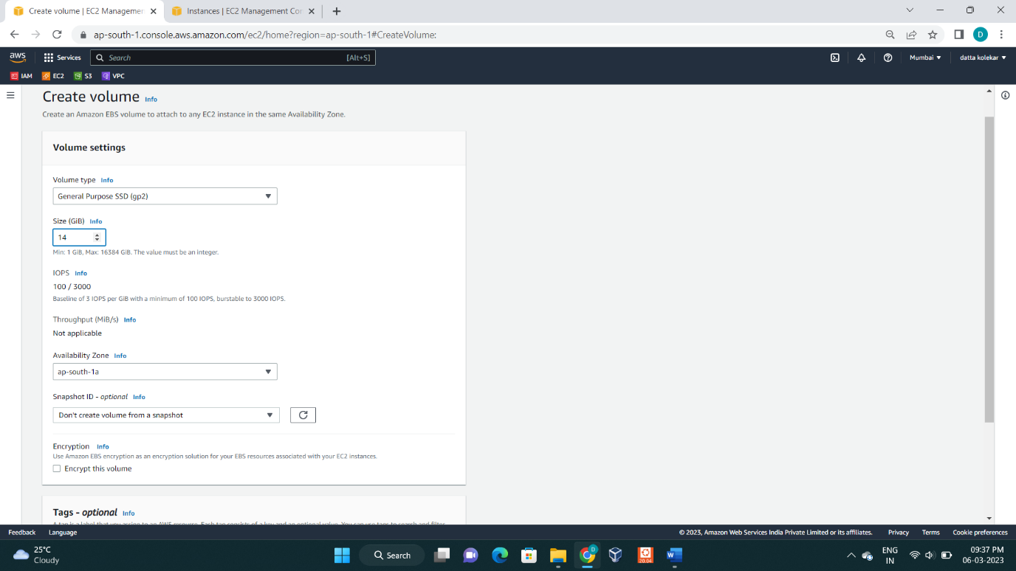

: Then select this volume and go to **Action** button

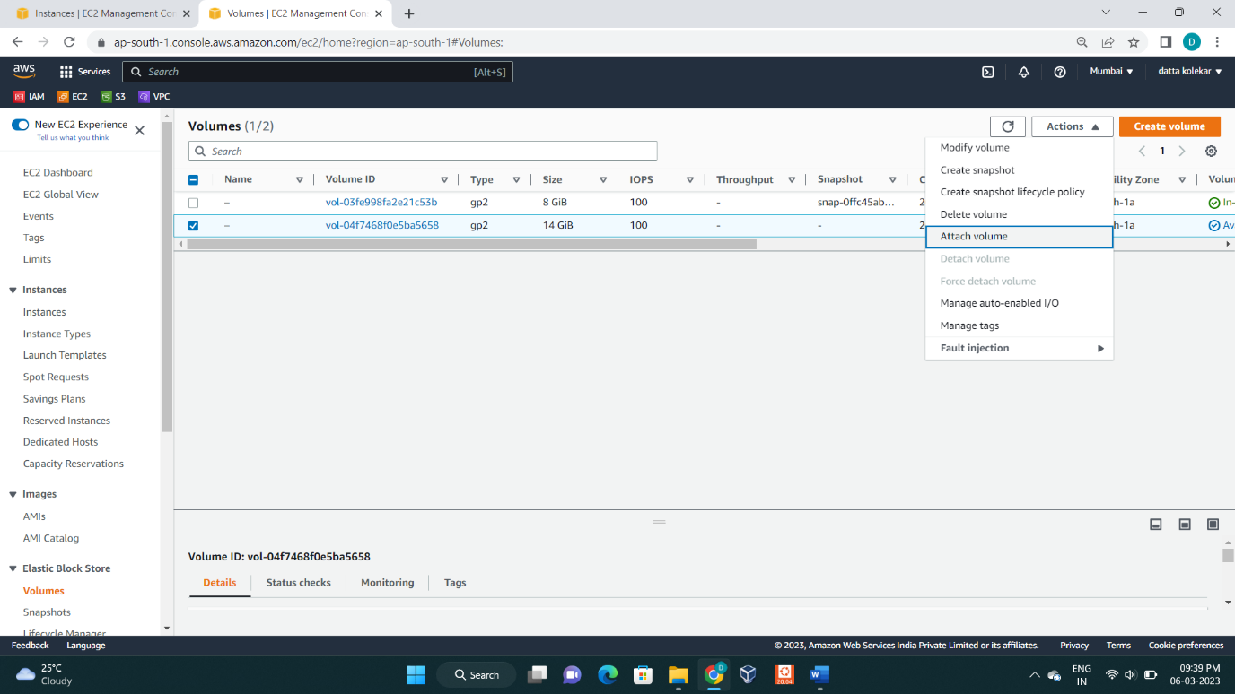

: Now click on **Attach volume**

: then select instance name click on **attach volume**.

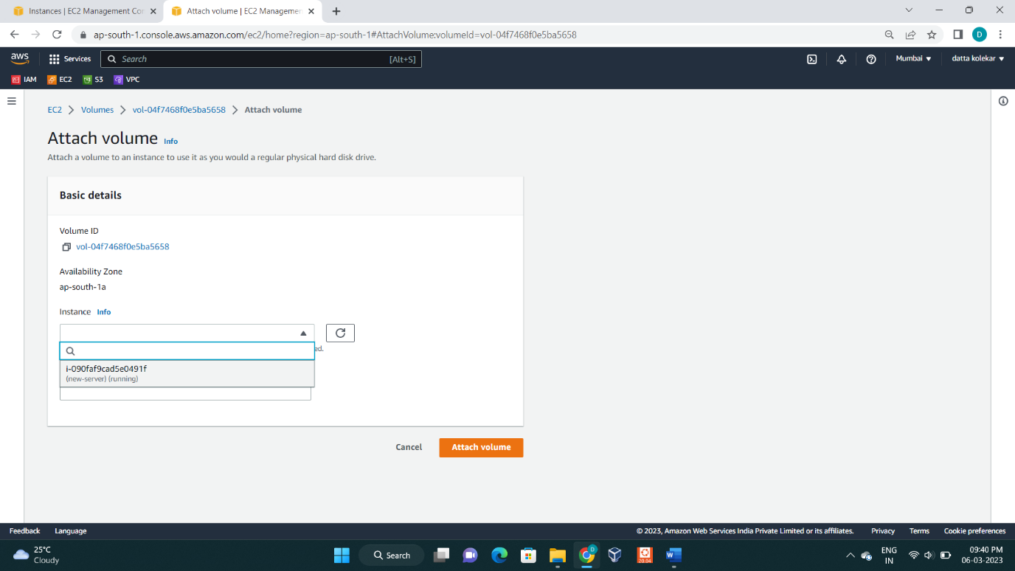

: Now volume attached to our instance

: Now go to **instance** and select this instance then click on **connect**

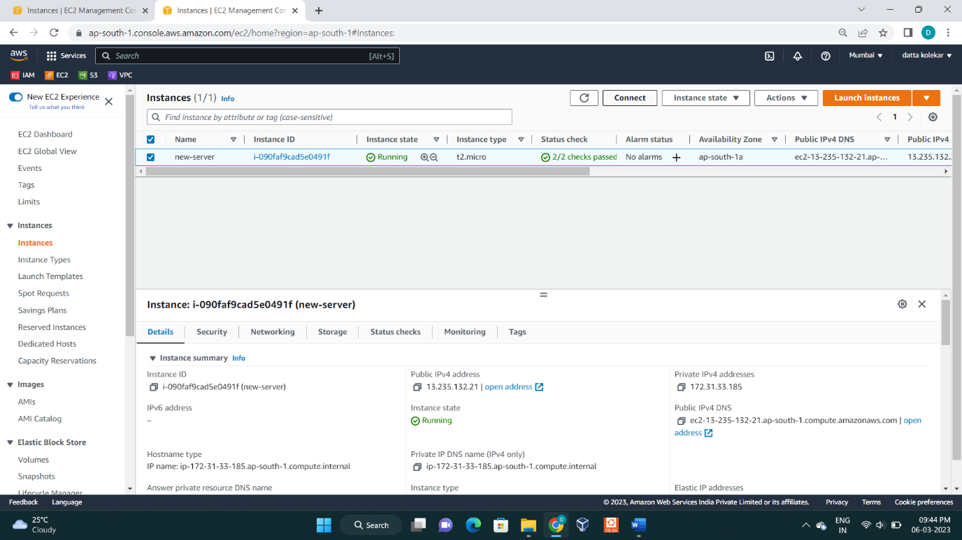

: Then in cli type commands this is shown in below image

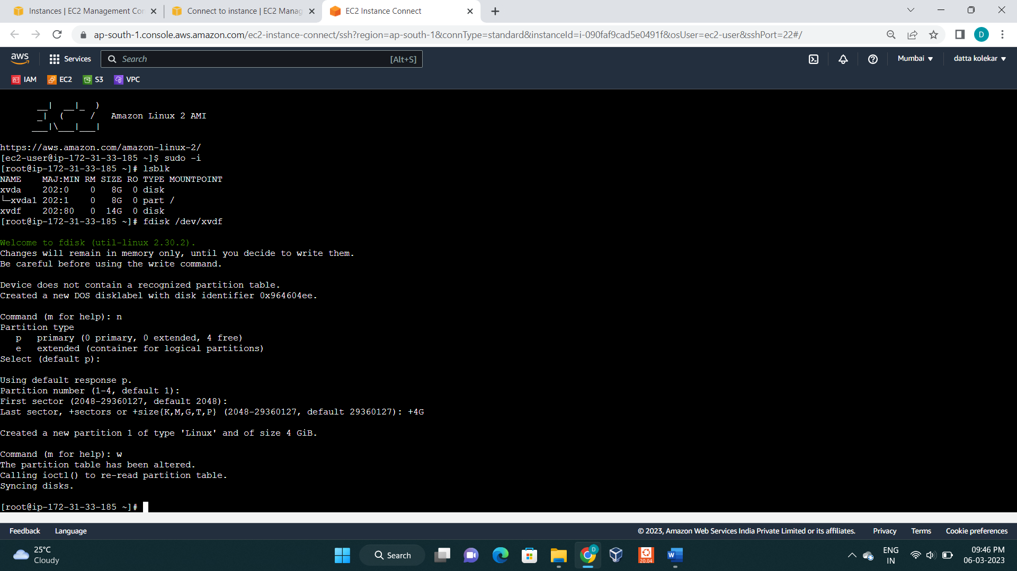

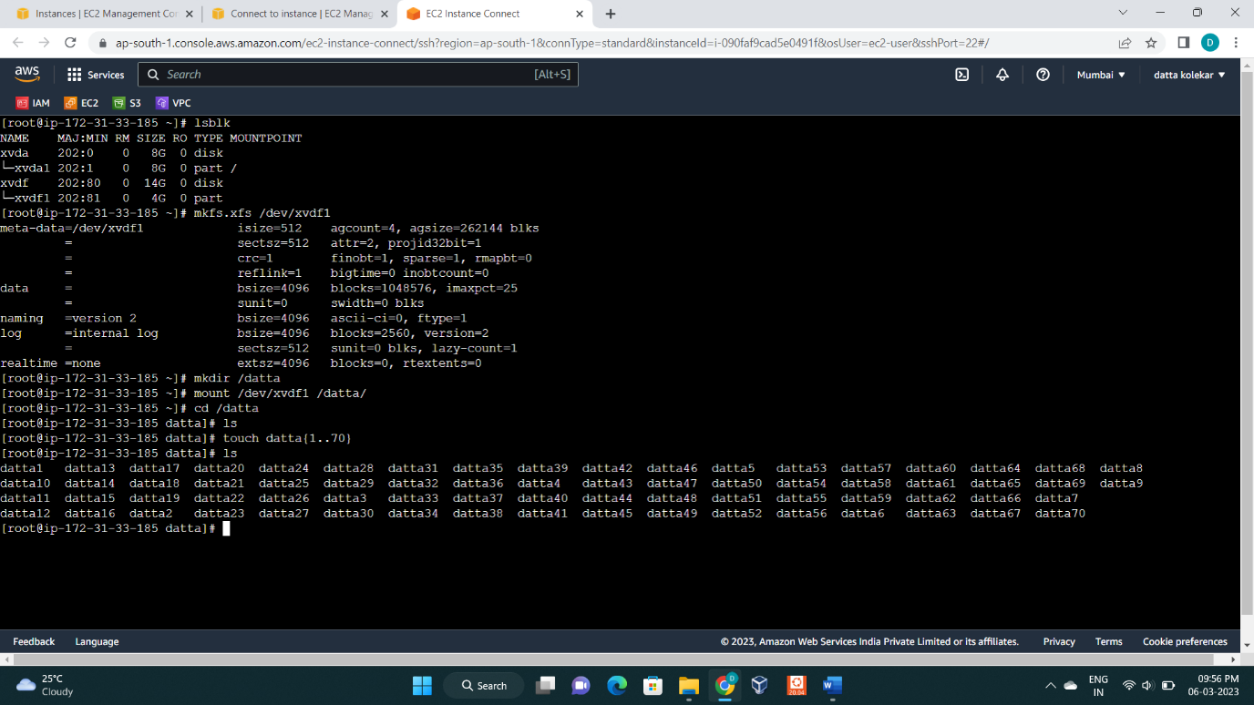

: Now go to **volumes** option and select we created volume

And go to **Action** button

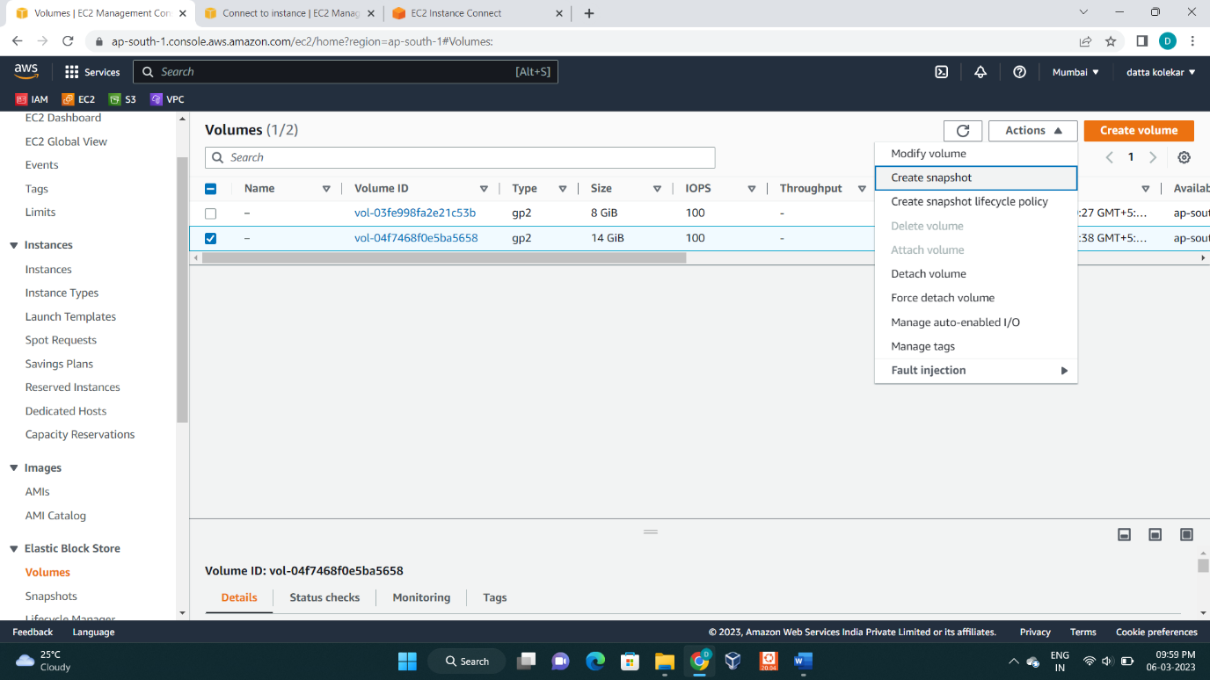

: Click on **create snapshot** and simply create snapshot without choosing any option.

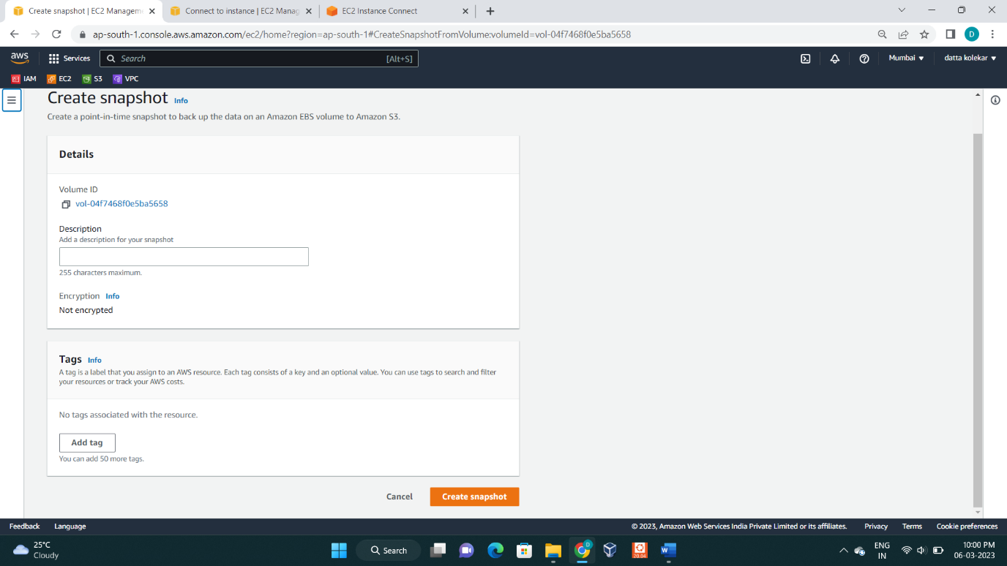

: Now go to **snapshots** option

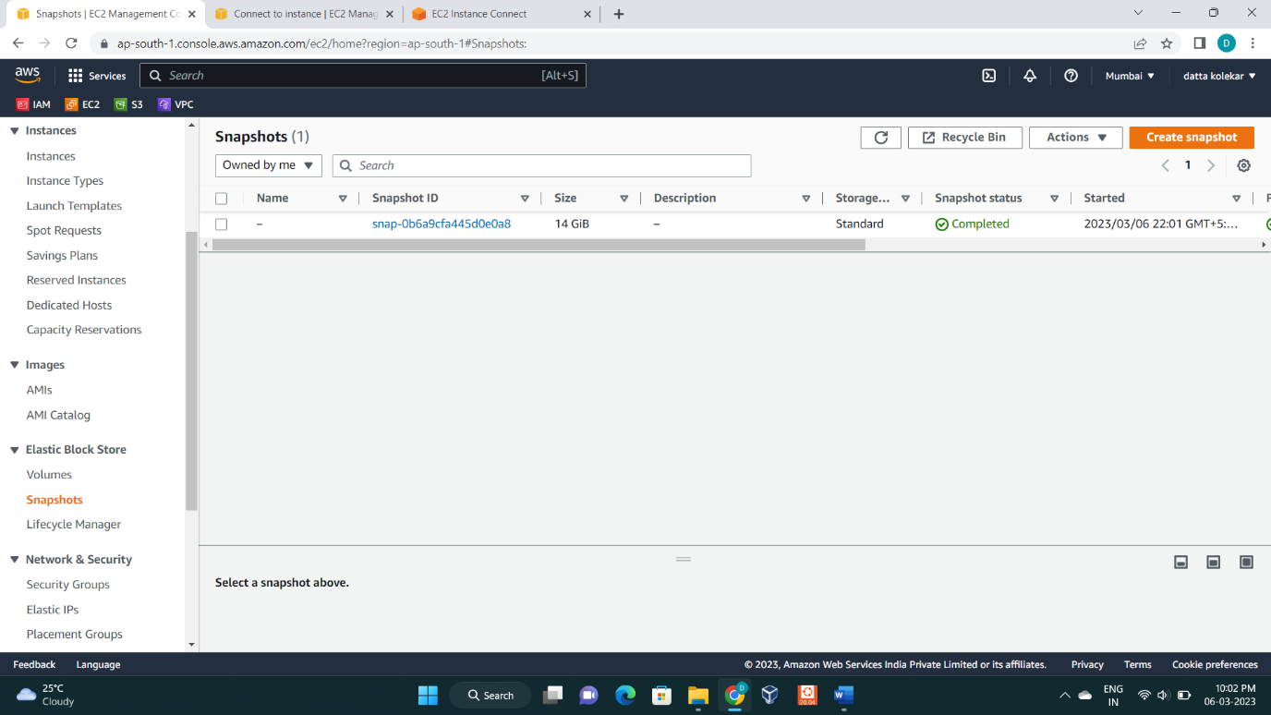

: Select this snapshot and click on **permission** option

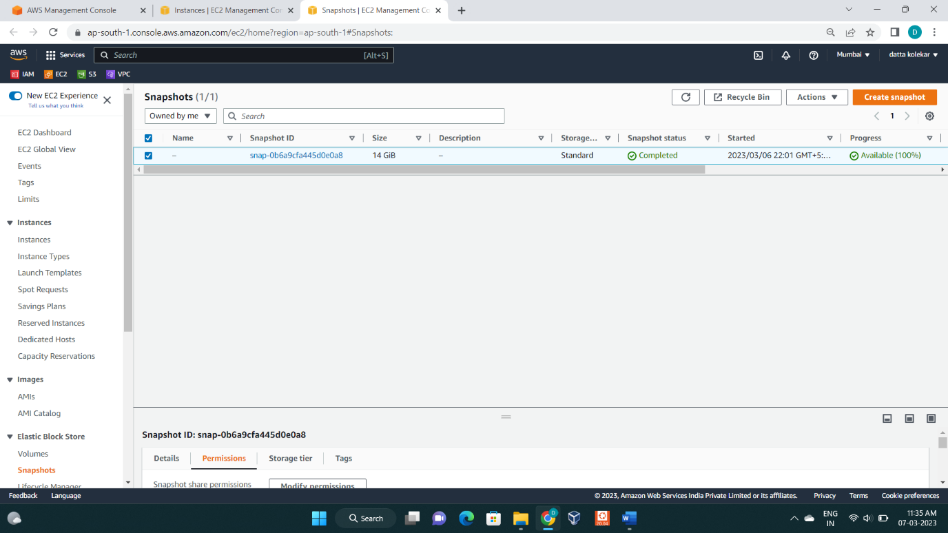

: And then click on **Add account Id**

Now show this interface

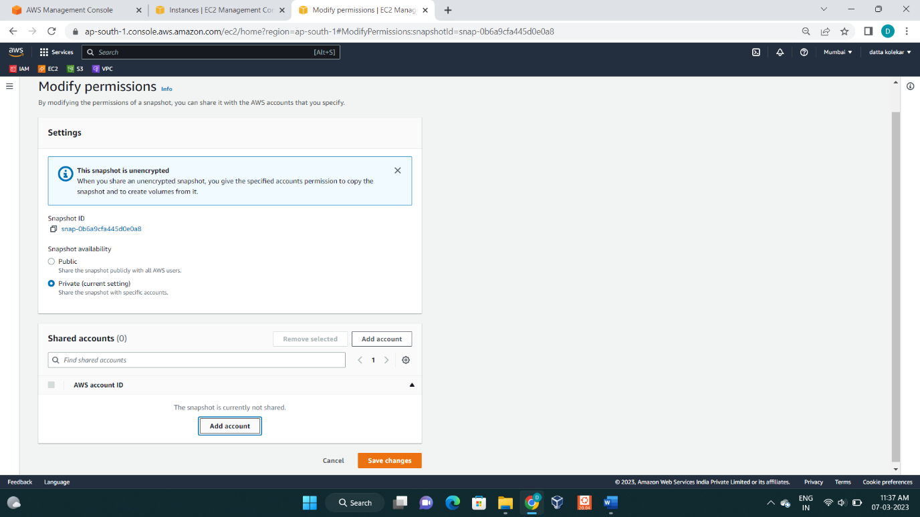

: Click on **add account**

: Now type AWS account ID of different account

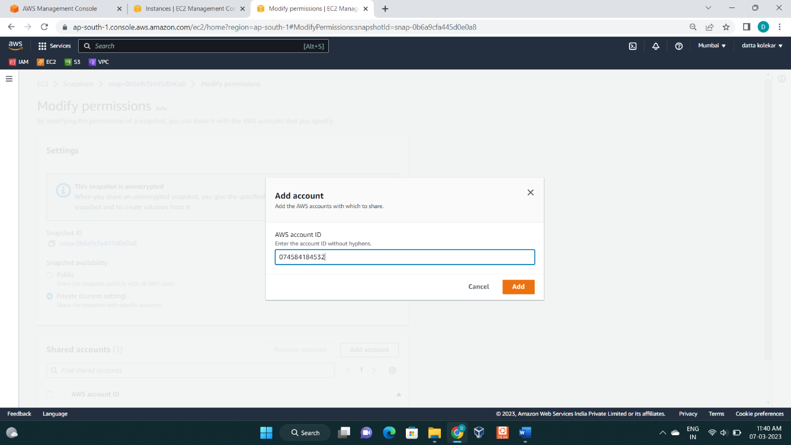

Then in **modify permissions** select account id and click on **save changes**

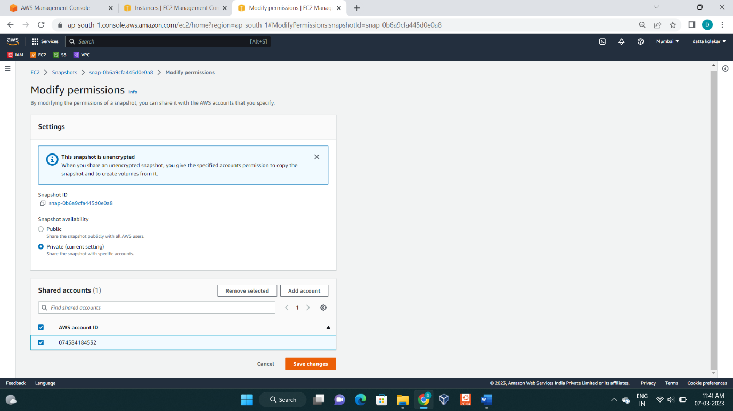

Now our snapshot is share to different account

Go to this account and create volume of share snapshot

Then one instance lunch and attach we created volume to this instance

And connect instance and in cli, mount this partition to one directory to show our first account data.